PERIOD 6-7 DBQ

DBQ MODIFIED FOR 2020 EXAM FORMAT

Directions: Question 1 is based on the accompanying documents. The documents have been edited for the purpose of this exercise. You will have 45 minutes to complete this DBQ.

In your response you should do the following:
- Respond to the prompt with a historically defensive thesis or claim that establishes a line of reasoning.
- Describe a broader historical context relevant to the prompt.
- Support an argument in response to the prompt using at least 4 documents.
- Use 2 additional pieces of specific historical evidence (beyond that found in the documents) relevant to an argument in the prompt.
- For at least 2 documents, explain how or why the documents point of view, purpose, historical situation, and/or audience is relevant to an argument.
- Use evidence to corroborate, qualify, or modify an argument that addresses the prompt.

1. To what extent was imperialism a “new” policy for the US or a continuation of previous expansionist policies?

Document 1
Source: Image from Carlisle Indian School, Pennsylvania, established in 1879, photo taken in 1883

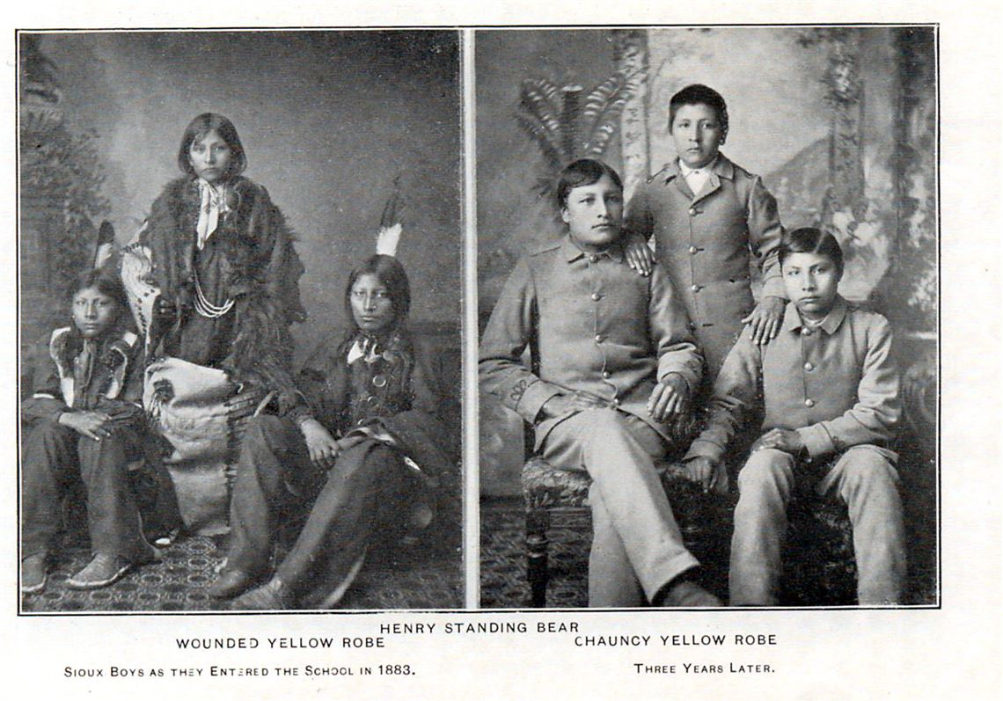

Document 2
Source: Helen Hunt Jackson, A Century of Dishonor published and sent a copy to every member of Congress, 1881

There is not among these three hundred bands of Indians [in the United States] one which has not suffered cruelly at the hands either of the Government or of white settlers. The poorer, the more insignificant, the more helpless the band, the more certain the cruelty and outrage to which they have been subjected. This is especially true of the bands on the Pacific slopes. These Indians found themselves of a sudden surrounded by and caught up in the great influx of gold-seeking settlers, as helpless creatures on a shore are caught up in a tidal wave. There was not time for the Government to make treaties; not even time for communities to make laws. The tale of the wrongs, the oppressions, the murders of the Pacific-slope Indians in the last thirty years would be a volume by itself, and is too monstrous to be believed...

Document 3
Source: Senator Albert J. Beverage: In Support of an American Empire, 1899

MR. PRESIDENT, the times call for candor. The Philippines are ours forever, "territory belonging to the United States," as the Constitution calls them. And just beyond the Philippines are China's illimitable markets. We will not retreat from either. We will not repudiate our duty in the archipelago. We will not abandon our opportunity in the Orient. We will not renounce our part in the mission of our race, trustee, under God, of the civilization of the world. And we will move forward to our work, not howling out regrets like slaves whipped to their burdens but with gratitude for a task worthy of our strength and thanksgiving to Almighty God that He has marked us as His chosen people, henceforth to lead in the regeneration of the world.

Document 4
Source: William McKinley, speech to a Methodist Church group, November 1899

"I walked the floor of the White House night after night until midnight; and I am not ashamed to tell you, gentlemen, that I went down on my knees and prayed Almighty God for light and guidance more than one night. And one night late it came to me this way...(1) that we could not give them back to Spain -- that would be cowardly and dishonorable; (2) that we could not turn them over to France or Germany -- our commercial rivals in the Orient -- that would be bad business and discreditable; (3) that we could not leave them to themselves -- they were unfit for self government -- and they would soon have anarchy and misrule worse than Spain's was; and (4) that there was nothing left for us to do but take them all, and to educate the Filipinos, and uplift and civilize them, and by God's grace do the very best we could by them..."

Document 5
Source: Peffer, W. A., "Imperialism: America's Historic Policy," The North American Review, vol. 171, issue 525 (August 1900).

The course of Americanism has been in natural order, a little rough sometimes, it is true, but that, too, is in the nature of things. What these people call imperialism is only mirage in the heated air of politics --- and it will entirely disappear when the snow flies again. The trouble with the Philippines has been occasioned by Aguinaldo and his associates. Americans are there of right, and they ask nothing of the natives but to go ahead with their business; they will not only be protected in every right, but will be aided by all powerful influences of an advanced and aggressive civilization.

