PERIOD 7 DBQ

DBQ MODIFIED FOR 2020 EXAM FORMAT

Directions: Question 1 is based on the accompanying documents. The documents have been edited for the purpose of this exercise. You will have 45 minutes to complete this DBQ.

In your response you should do the following:
- Respond to the prompt with a historically defensive thesis or claim that establishes a line of reasoning.
- Describe a broader historical context relevant to the prompt.
- Support an argument in response to the prompt using at least 4 documents.
- Use 2 additional pieces of specific historical evidence (beyond that found in the documents) relevant to an argument in the prompt.
- For at least 2 documents, explain how or why the documents point of view, purpose, historical situation, and/or audience is relevant to an argument.
- Use evidence to corroborate, qualify, or modify an argument that addresses the prompt.

1. Analyze the debates over American foreign policy from the end of the First World War (1918) to the end of World War II (1945).

Document 1
Source: Senator Henry Cabot Lodge, Sr., speech to the United States Senate Committee on Foreign Relations, 1919.

I have never had but one allegiance—I cannot divide it now. I have loved but one flag and I cannot share that devotion and give affection to the mongrel banner invented for a league. Internationalism, illustrated by the Bolshevik . . . is to me repulsive. . . . The United States is the world’s best hope, but if you fetter her in the interests and quarrels of other nations, if you tangle her in the intrigues of Europe, you will destroy her power for good and endanger her very existence. . . . No doubt many excellent and patriotic people see a coming fulfillment of noble ideals in the words “league for peace.” We all respect and share these aspirations and desires, but some of us see no hope, but rather defeat, for them in this murky covenant. For we, too, have our ideals, even if we differ from those who have tried to establish a monopoly of idealism.

Document 2
Source: John T. McCutcheon “Misplaced Economy” Chicago Daily Tribune, 1922

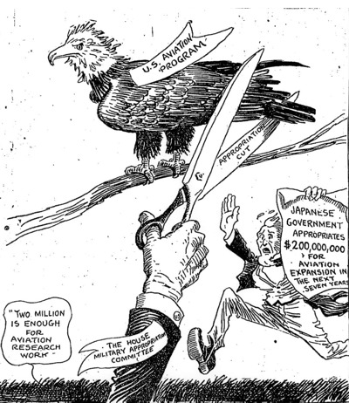

Document 3
Source: Senator Gerald P. Nye, speech before the “Keep America Out of War” meeting, New York City, May 27, 1935.

Let us know that it is sales and shipments of munitions and contraband, and the lure of the profits in them, that will get us into another war, and that when the proper time comes and we talk about national honor, let us know that simply means the right to go on making money out of a war. . . . The experience of the last war includes the lesson
that neutral rights are not a matter for national protection unless we are prepared to protect them by force. . . . I believe . . . that the only hope of staying out of war is through our people recognizing and declaring as a matter of . . . national policy, that we will not ship munitions to aid combatants and that those of our citizens who ship other materials to belligerent nations must do so at their own risk and without any hope of protection from our Government. If our financiers and industrialists wish to speculate for war profits, let them be warned in advance that they are to be limited to speculation with their own capital and not with the lives of their countrymen and the fabric of their whole nation.

Document 4
Source: President Franklin Roosevelt, speech, Chicago, October 5, 1937.

The political situation in the world . . . has been growing progressively worse. . . . The present reign of terror and international lawlessness began a few years ago . . . through unjustified interference in the internal affairs of other nations or the invasion of alien territory in violation of treaties; . . . The peace-loving nations must make a concerted
effort in opposition to those violations of treaties and those ignorings of humane instincts which today are creating a state of international anarchy and instability from which there is no escape through mere isolation or neutrality. . . . There can be no stability or peace either within nations or between nations except under laws and moral standards adhered to by all. . . . It seems to be unfortunately true that the epidemic of world lawlessness is spreading. When an epidemic of physical disease starts to spread, the community approves and joins in a quarantine of the patients in order to protect the health of the community against the spread of the disease.

Document 5
Source: Poll on what the proper role and powers of the United Nations should be, Roper Research Center, Cornell University, 1945.
