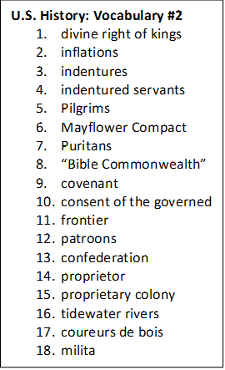

**U.S. History: Vocabulary #2**

1. divine right of kings
2. inflations
3. indentures
4. indentured servants
5. Pilgrims
6. Mayflower Compact
7. Puritans
8. “Bible Commonwealth”
9. covenant
10. consent of the governed
11. frontier
12. patroons
13. confederation
14. proprietor
15. proprietary colony
16. tidewater rivers
17. coureurs de bois
18. milita

**U.S. History: Vocabulary #2**

1. divine right of kings
2. inflations
3. indentures
4. indentured servants
5. Pilgrims
6. Mayflower Compact
7. Puritans
8. “Bible Commonwealth”
9. covenant
10. consent of the governed
11. frontier
12. patroons
13. confederation
14. proprietor
15. proprietary colony
16. tidewater rivers
17. coureurs de bois
18. milita