PERIOD 2-5 DBQ

DBQ MODIFIED FOR 2020 EXAM FORMAT

Directions: Question 1 is based on the accompanying documents. The documents have been edited for the purpose of this exercise. You will have 45 minutes to complete this DBQ.

In your response you should do the following:
- Respond to the prompt with a historically defensive thesis or claim that establishes a line of reasoning.
- Describe a broader historical context relevant to the prompt.
- Support an argument in response to the prompt using at least 4 documents.
- Use 2 additional pieces of specific historical evidence (beyond that found in the documents) relevant to an argument in the prompt.
- For at least 2 documents, explain how or why the documents point of view, purpose, historical situation, and/or audience is relevant to an argument.
- Use evidence to corroborate, qualify, or modify an argument that addresses the prompt.

- Analyze the factors which impacted the roles of women from 1776 to 1865.
Document 1
Source: Elizabeth Mifflin of Philadelphia, letter to a friend in Boston, 1776.
I will tell you what I have done… I have retrenched every superfluous expense in my table and family; tea I have not drunk since last Christmas, nor bought a new cap or gown… [I] have learned to knit, and am now making stockings of American wool for my servants, and this way do I throw in my mite to the public good. I know this, that as free I can die but once, but as a slave I shall not be worthy of life. I have the pleasure to assure you that these are the sentiments of my sister Americans. They have sacrificed assemblies, parties of pleasure, tea-drinkings, and finery to that great spirit of patriotism which actuates all degrees of people through this extensive country.

Document 2
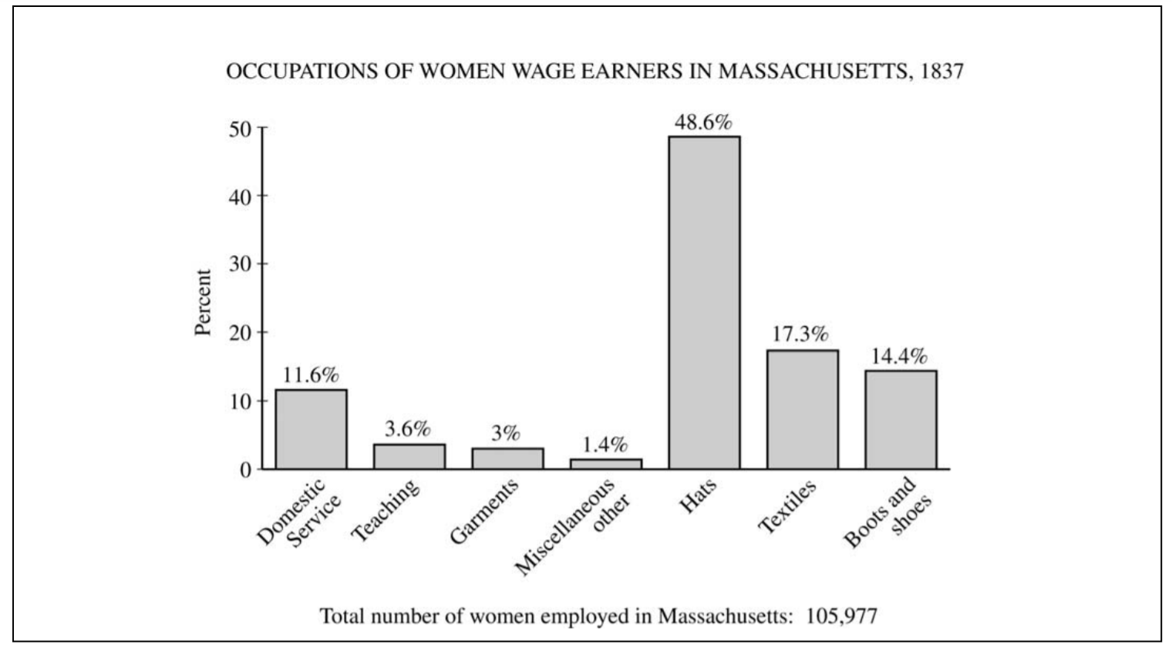

Document 3
Source: Editorial cartoon, Harper’s Weekly Magazine, 1859
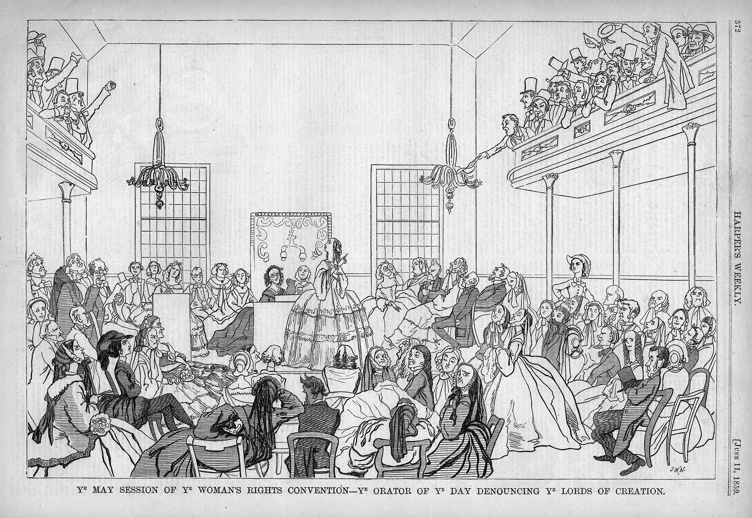

Document 4
Source: pamphlet from the Woman's Central Association of Relief, New York, 1863
Having seen something abroad of the usual frightful mortality among soldiers in actual war, and read more; and having seen too the manner in which our volunteers were hurried into the field, I believe that the mortality among them would have been vastly greater but for the existence of the Sanitary Commission.

I believe this after giving due weight to the fact that certain officers sneer at the Commission; and to the really important fact that the season has been uncommonly favorable.

The United States Sanitary Commission, projected and animated by its able and energetic president; organized and directed by its wise and humane secretary, has indeed done a great work in the way of preventing disease; the credit of which is due almost entirely to those officers, and to the zealous inspectors and assistants whom they have employed.

Document 5
Source: Susan B. Anthony, speech at the first meeting of the National Loyal League in New York City, 1863
They have had no right to vote in their churches, and, like slaves, have meekly accepted whatever morals and religion the selfish interest of politics and trade dictated. Woman must now assume her God-given responsibilities, and make herself what she is clearly designed to be, the educator of the race. Let her no longer be the mere reflector, the echo of the worldly pride and ambition of man. (Applause).
Had the women of the North studied to know and to teach their sons the law of justice to the black man, regardless of the frown or the smile of pro-slavery priest and politician, they would not now be called upon to offer the loved of their households to the bloody Moloch of war. And now, women of the North, I ask you to rise up with earnest, honest purpose, and go forward in the way of right, fearlessly, as independent human beings, responsible to God alone for the discharge of every duty, for the faithful use of every gift, the good Father has given you. Forget conventionalisms; forget what the world will say, whether you are in your place or out of your place; think your best thoughts, speak your best words, do your best works, looking to your own conscience for approval.

