PERIOD 7 DBQ

DBQ MODIFIED FOR 2020 EXAM FORMAT

Directions: Question 1 is based on the accompanying documents. The documents have been edited for the purpose of this exercise. You will have 45 minutes to complete this DBQ.

In your response you should do the following:
- Respond to the prompt with a historically defensive thesis or claim that establishes a line of reasoning.
- Describe a broader historical context relevant to the prompt.
- Support an argument in response to the prompt using at least 4 documents.
- Use 2 additional pieces of specific historical evidence (beyond that found in the documents) relevant to an argument in the prompt.
- For at least 2 documents, explain how or why the documents point of view, purpose, historical situation, and/or audience is relevant to an argument.
- Use evidence to corroborate, qualify, or modify an argument that addresses the prompt.

1. Evaluate how the responses of Franklin D. Roosevelt’s administration to the problems of the Great Depression changed the role of the federal government.

Document 1
Source: Franklin D. Roosevelt’s Fireside Chat on the Banking Crisis, 1933.

By the afternoon of March 3 scarcely a bank in the country was open to do business. Proclamations temporarily closing them in whole or in part had been issued by the Governors in almost all the states.

It was then that I issued the proclamation providing for the nation-wide bank holiday, and this was the first step in the Government's reconstruction of our financial and economic fabric. The second step was the legislation promptly and patriotically passed by the Congress confirming my proclamation and broadening my powers so that it became possible in view of the requirement of time to entend (sic) the holiday and lift the ban of that holiday gradually. This law also gave authority to develop a program of rehabilitation of our banking facilities. I want to tell our citizens in every part of the Nation that the national Congress -- Republicans and Democrats alike -- showed by this action a devotion to public welfare and a realization of the emergency and the necessity for speed that it is difficult to match in our history.

Document 2
Source: Letter to Senator Robert Wagner, March 7, 1934.

It seems very apparent to me that the Administration at Washington is accelerating it’s [sic] pace towards socialism and communism. Nearly every public statement from Washington is against stimulation of business which would in the end create employment. Everyone is sympathetic to the cause of creating more jobs and better wages for labor; but,
a program continually promoting labor troubles, higher wages, shorter hours, and less profits for business, would seem to me to be leading us fast to a condition where the Government must more and more expand it’s relief activities, and will lead in the end to disaster to all

Document 3
Source: Cliff Berryman, cartoon published in the Washington Star, 1934.

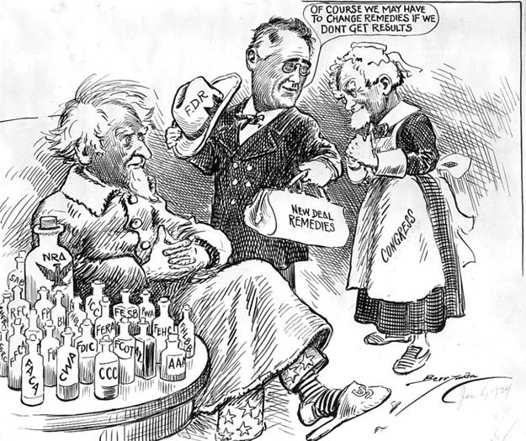

Document 4
Source: American Liberty League Pamphlet, The New Deal versus Democracy, 1936.
The New Deal has harassed American business and has entered into competition in almost every possible way with private industry.
The New Deal has misused the Federal taxing power in an effort to promote visionary schemes for the redistribution of wealth.
The New Deal has imposed taxes heavier than were ever before placed upon the nation in time of peace and by reckless borrowing has saddled huge obligations upon generations yet unborn.
The New Deal has led the nation far along the road toward national bankruptcy and has increased the national debt to unprecedented size.
The New Deal has manifested its contempt for constitutional government.
The New Deal has sought to make the Legislative Branch of the government subservient to the will of the Executive.

Document 5
Source: Rose Dudley Scearce, “What REA [Rural Electrification Administration] Service Means to Our Farm Home,” Kentucky, 1939.
THE FIRST benefit we received from the REA service was lights, and aren’t lights grand? My little boy expressed my sentiments when he said, “Mother, I didn’t realize how dark our house was until we got electric lights.” ...
Recently I read in the Rural Electrification NEWS that the radio was the most popular appliance that had been bought. So, like the rest of the people, we changed our storage-battery radio into an electric radio. This was our next benefit.
Next we bought an electric refrigerator. Of course, next after a refrigerator comes making ice cream in the trays. We changed our washing machine from a machine driven by gasoline to one driven by the electric current as our next improvement. The machine was all right with gasoline, but, my, the noise it made!

