PERIOD 6 DBQ

DBQ MODIFIED FOR 2020 EXAM FORMAT

Directions: Question 1 is based on the accompanying documents. The documents have been edited for the purpose of this exercise. You will have 45 minutes to complete this DBQ.

In your response you should do the following:
- Respond to the prompt with a historically defensive thesis or claim that establishes a line of reasoning.
- Describe a broader historical context relevant to the prompt.
- Support an argument in response to the prompt using at least 4 documents.
- Use 2 additional pieces of specific historical evidence (beyond that found in the documents) relevant to an argument in the prompt.
- For at least 2 documents, explain how or why the documents point of view, purpose, historical situation, and/or audience is relevant to an argument.
- Use evidence to corroborate, qualify, or modify an argument that addresses the prompt.

- Evaluate the extent to which the Progressive movement fostered political change in the United States from 1890 to 1920.
Document 1
Source: Jacob Riis, photojournalist, How the Other Half Lives, New York City, 1890.

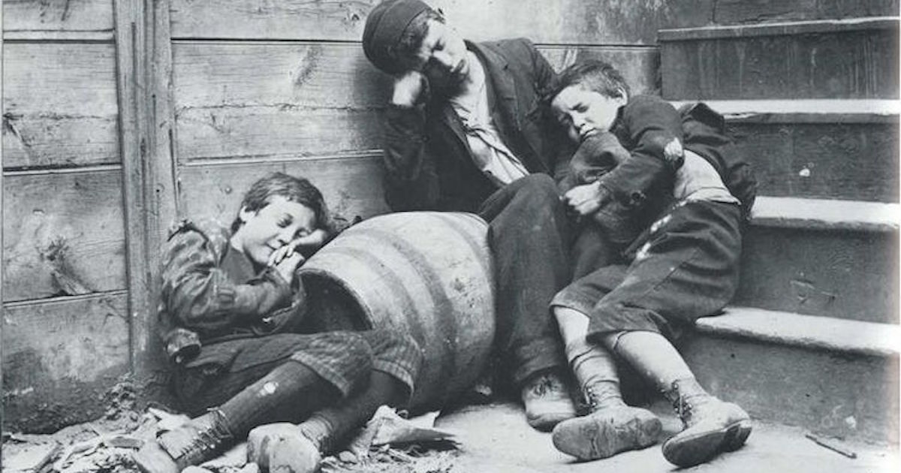

Document 2
Source: President Theodore Roosevelt, speech at Providence, Rhode Island, 1902.

The great corporations which we have grown to speak of rather loosely as trusts are the creatures of the State, and the State not only has the right to control them, but it is in duty bound to control them wherever the need of such control is shown. There is clearly need of supervision—need to possess the power of regulation of these great corporations through the representatives of the public—wherever, as in our own country at the present time, business corporations become so very powerful alike for beneficent work and for work that is not always beneficent. It is idle to say that there is no need for such supervision. There is, and a sufficient warrant for it is to be found in any one of the admitted evils appertaining to them.

Document 3
Source: Ida Tarbell, “The History of the Standard Oil Company,” McClure’s Magazine, 1902-1904

Mr. Rockefeller . . . secured an alliance with the railroads to drive out rivals. For fifteen years he received rebates of varying amounts on at least the greater part of his shipments, and for at least a portion of that time he collected drawbacks of the oil other people shipped; at the same time he worked with the railroads to prevent other people getting oil to manufacture, or if they got it he worked with the railroads to prevent the shipment of the product. If it reached a dealer, he did his utmost to bully or wheedle him to countermand his order. If he failed in that, he undersold until the dealer, losing on his purchase, was glad enough to buy thereafter of Mr. Rockefeller. . . . . . . There is no independent refiner or jobber who tries to ship oil freight that does not meet incessant discouragement and discrimination. . .

Document 4
Clayton Anti-Trust Act, 1914

It shall be unlawful for any person engaged in commerce, in the course of such commerce, either directly or indirectly, to discriminate in price between different purchasers of commodities of like grade and quality, where either or any of the purchases involved in such discrimination are in commerce, where such commodities are sold for use, consumption, or resale within the United States or any Territory thereof or the District of Columbia or any insular possession or other place under the jurisdiction of the United States, and where the effect of such discrimination may be substantially to lessen competition or tend to create a monopoly in any line of commerce, or to injure, destroy, or prevent competition with any person who either grants or knowingly receives the benefit of such discrimination, or with customers of either of them...

That the Federal Trade Commission may, after due investigation and hearing to all interested parties, fix and establish quantity limits, and revise the same as it finds necessary, as to particular commodities or classes of commodities, where it finds that available purchasers in greater quantities are so few as to render differentials on account thereof unjustly discriminatory or promotive of monopoly in any line of commerce

Document 5
Source: The American Issue Publishing Company, a printer and distributor of pamphlets, leaflets, magazines, and books created by the Anti-Saloon League, circa 1918.
